# Request:

1. **Frame:**

The Frame number is 58482 from an Ethernet link. The total amount of transmitted data is 578 bytes. It uses Ethernet encapsulation on a designated interface. The arrival time of this packet is Feb 17, 2024 18:54:56.174349000 UTC. Epoch time acts as a measure of the elapsed duration from a reference point. Time delta from previous captured frame: 0.000025000 seconds. The packet encompasses various protocols including Ethernet, IP, TCP, and HTTP, indicating its nature as a web packet with a coloring rule applied.

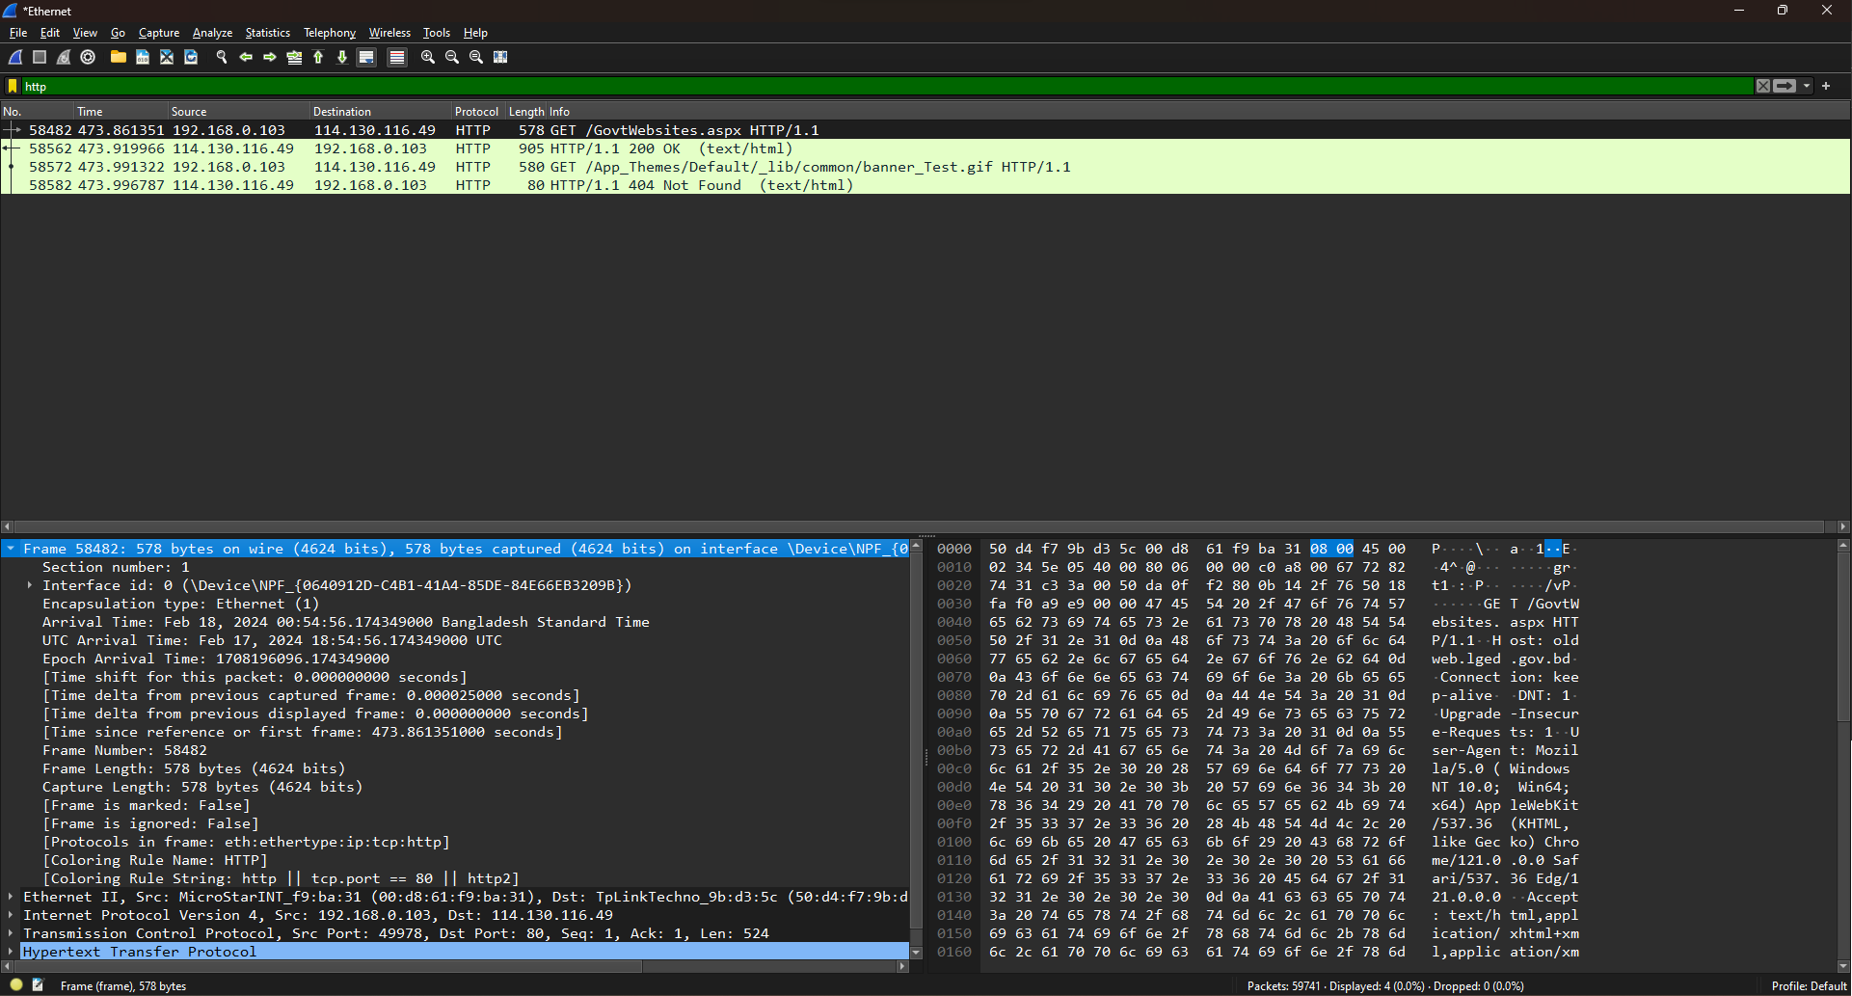

1. **Ethernet II:**

The frame contains IPv4 data. The source MAC address is MicroStarINT_f9:ba:31 (00:d8:61:f9:ba:31) and the destination MAC address is TpLinkTechno_9b:d3:5c (50:d4:f7:9b:d3:5c)

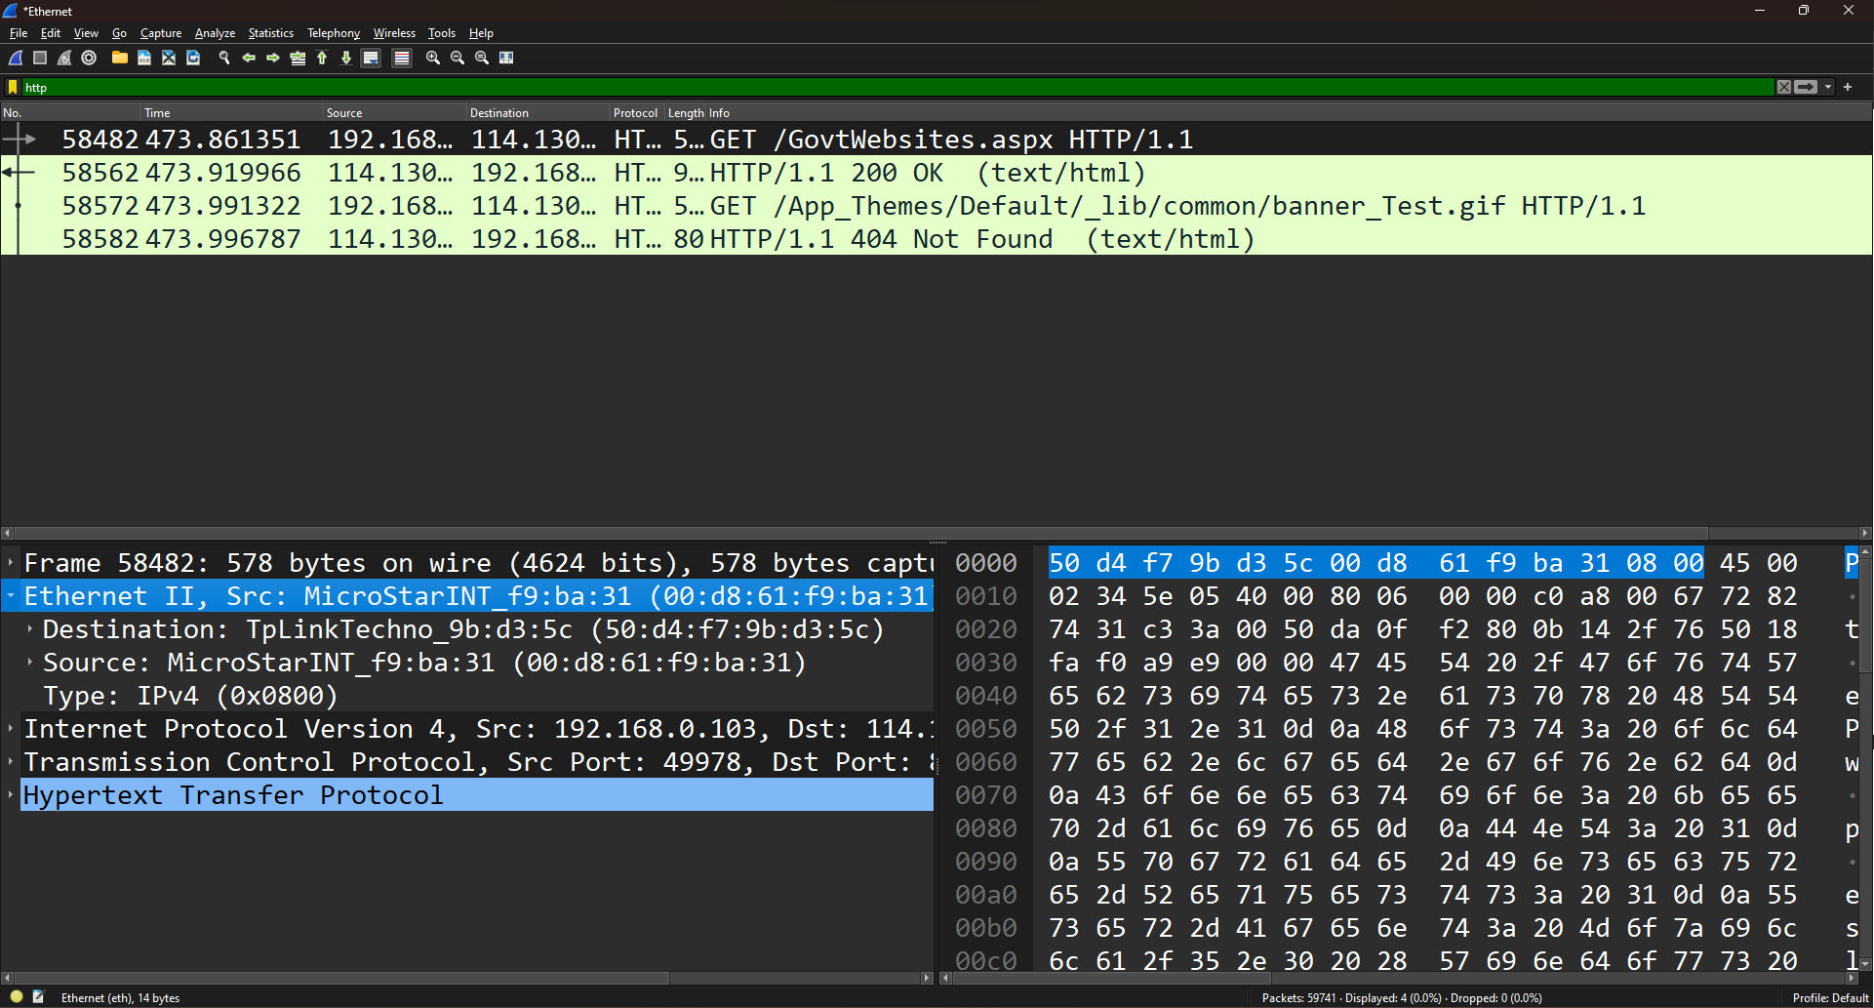

1. **Internet Protocol Version 4 (IPv4):**

For this IPv4 packet source IP address is 192.168.0.103 and destination IP address is 114.130.116.49. Total length is 564 bytes. Also it can’t be fragmented while transmitting. With a Time to Live (TTL) of 128, the packet is limited to 128 network hops before it's discarded. The packet utilizes TCP/IPv4, indicating that its payload protocol is TCP, signifying the transfer of reliable data within an IPv4 network.

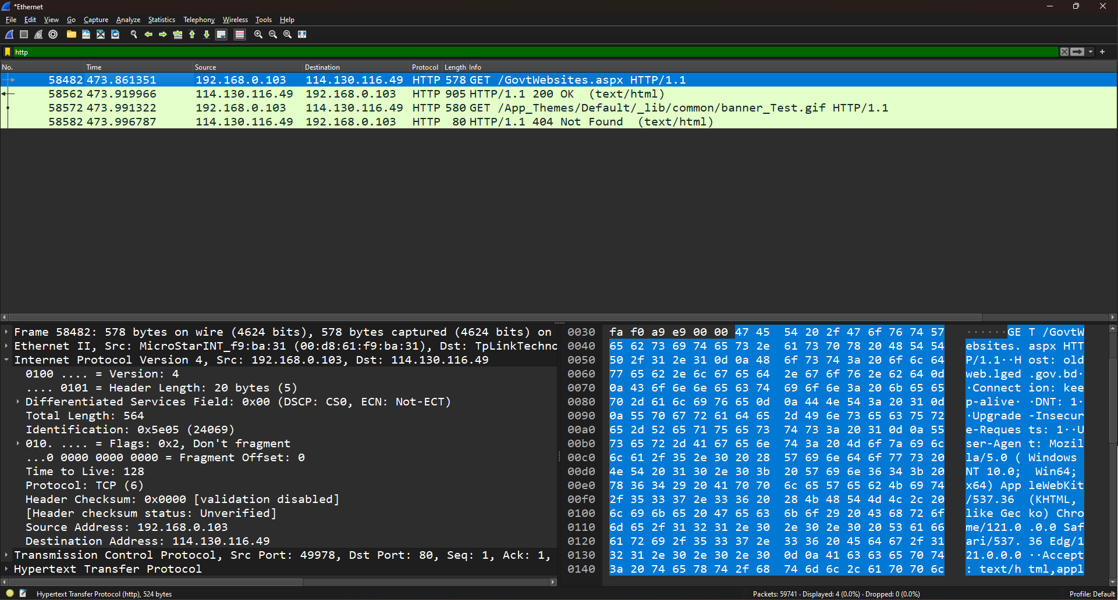

1. **TCP:**

A Transmission Control Protocol (TCP) segment serves as a unit for transmitting data across a network. Originating from source port 49978 and directed towards destination port 80, this data packet marks the beginning of a specific session. It acknowledges the receipt of the preceding packet, denoted by an acknowledgment number of 1. Marked with flags PSH (Push) and ACK (Acknowledgement), it indicates both data pushing and acknowledgment of a prior transmission. The window size of 64240 signifies the amount of data the sender is prepared to transmit without awaiting acknowledgment. This segment comprises 524 bytes of data. While its verification status remains unchecked, its checksum value is 0xa9e9. Notably, urgent pointers are absent in this section, and additional details regarding timestamps and SEQ/ACK analysis may exist but are not provided in the given data.

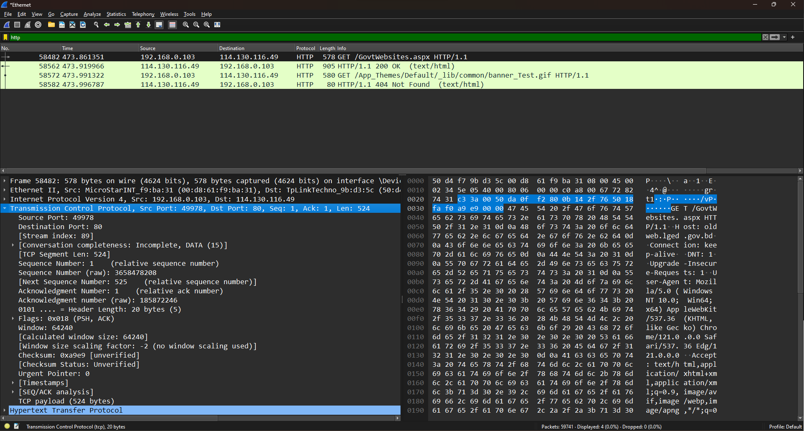

1. **HTTP:**

This is an HTTP GET request sent to the oldweb.lged.gov.bd server. It's specifically targeting the resource located at /GovtWebsites.aspx and utilizing HTTP version 1.1.

Several headers accompany the request line. The "Host" header specifies the target server, while "Connection" is set to keep the connection open for potential future requests. The "Accept" header indicates the client's ability to accept any type of response. The "User-Agent" header identifies the client as a Windows-based system running Chrome. "Accept-Encoding" informs the server that the client can handle gzip and deflate compression techniques for the response. Lastly, "Accept-Language" specifies the preferred language for the response. The request's termination is marked by two newline characters after the headers. This request marks the beginning of a session comprising 2 HTTP requests.

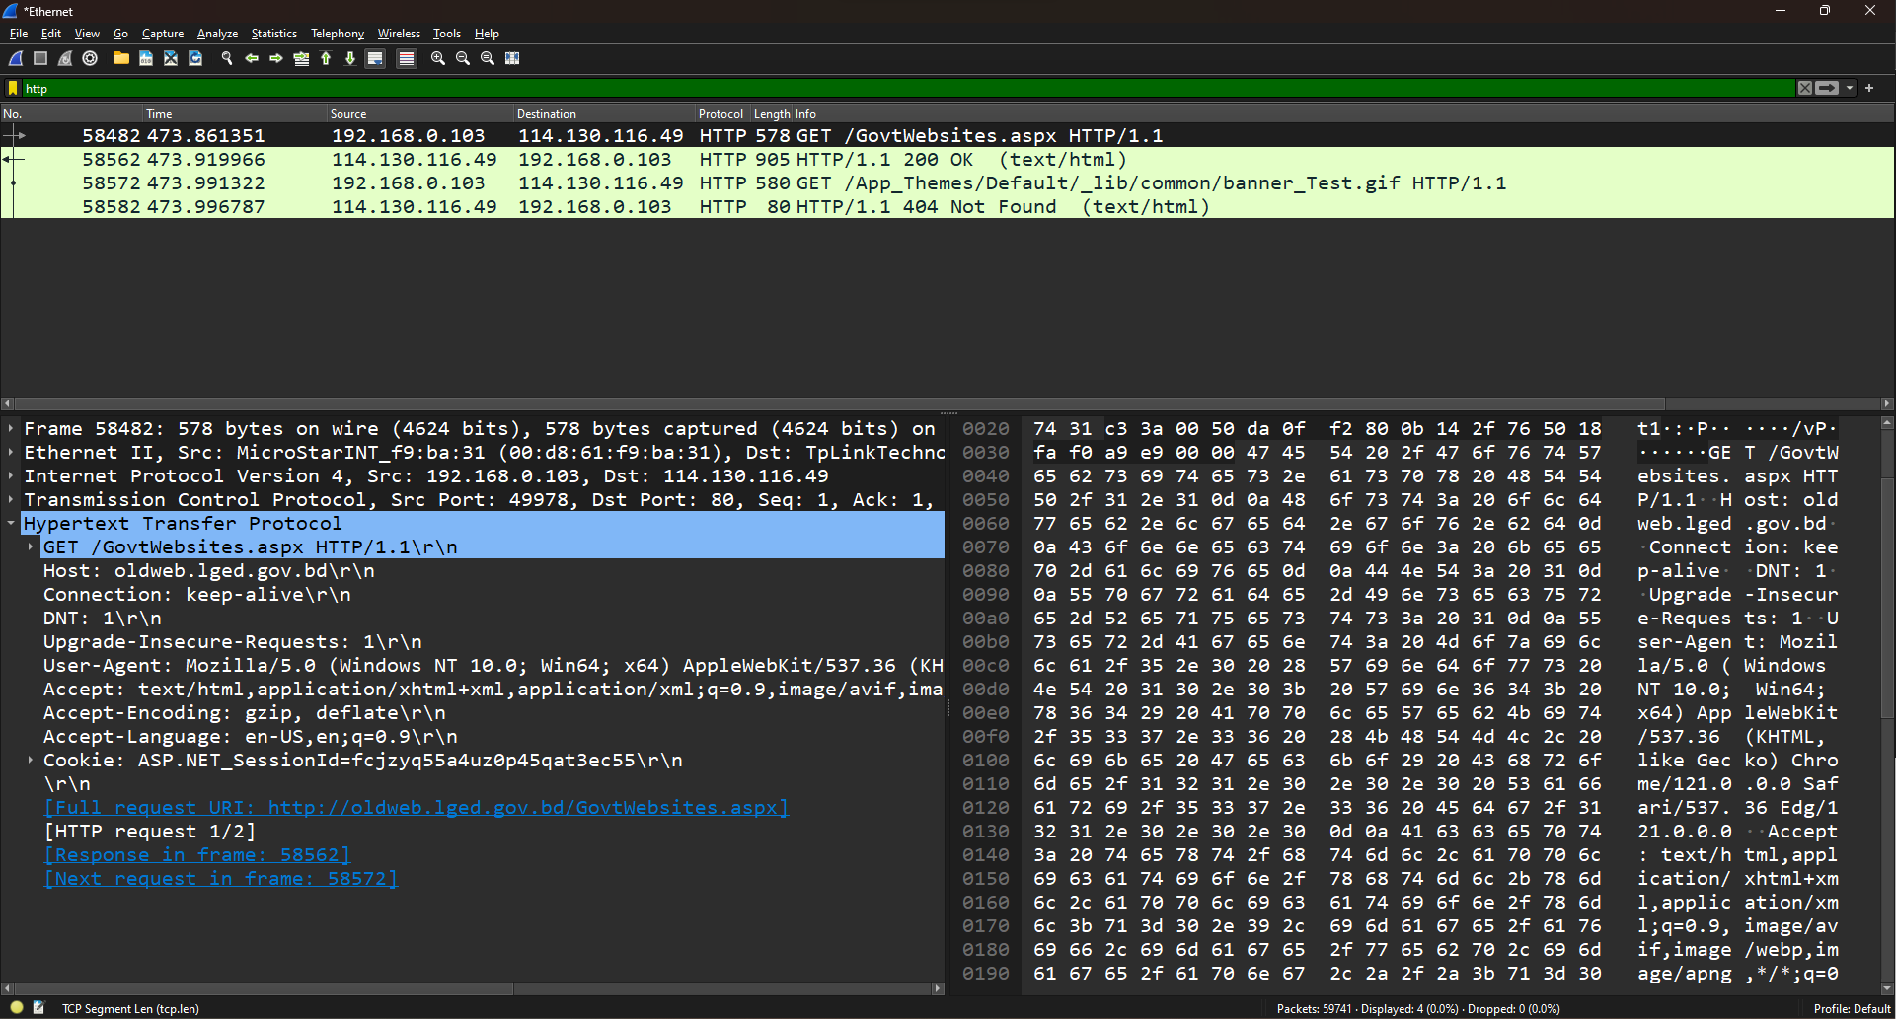

# Response:

1. **Frame:**

This is frame 58562 intercepted from the network, containing 905 bytes of data transmitted via Ethernet. The data-text-lines encapsulate information related to different protocols like IP, TCP, and HTTP, indicating various layers of network communication. Specifically, this frame represents an HTTP packet, highlighting its role in facilitating web communication.

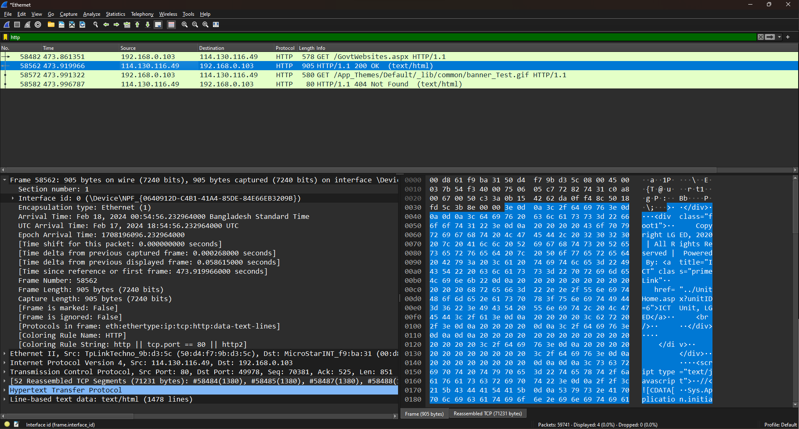

1. **Ethernet II:**

The frame contains IPv4 data. The source MAC address is TpLinkTechno_9b:d3:5c (50:d4:f7:9b:d3:5c) and the destination MAC address is MicroStarINT_f9:ba:31 (00:d8:61:f9:ba:31)

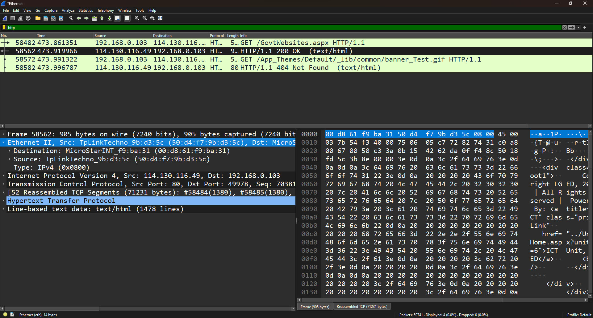

1. **Internet Protocol Version 4 (IPv4):**

This IPv4 packet originates from the IP address 114.130.116.49 and is destined for 192.168.0.103. It has a length of 891 bytes and contains TCP data. The packet is configured not to fragment during transmission, and it has a Time to Live (TTL) value of 117. Although the header checksum is calculated as 0x05c7, it appears that the checksum validation is disabled.

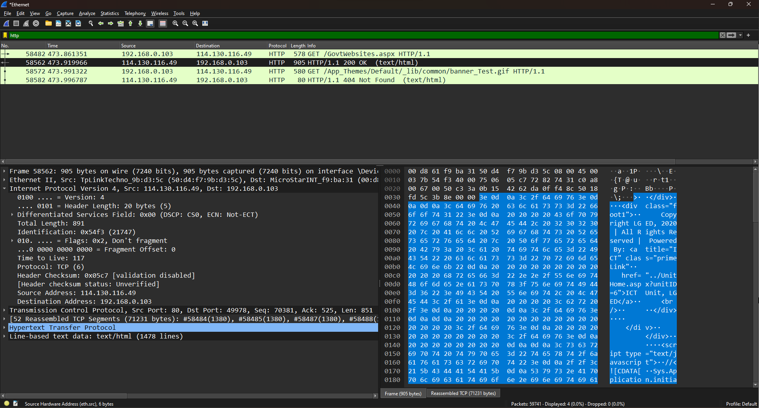

1. **TCP:**

This TCP segment has a source port of 80 and a destination port of 49978. It marks the 71232 packet within this session and acknowledges the receipt of the preceding packet with an acknowledgment number of 525. Indicated by the flags PSH and ACK, this segment both pushes data and acknowledges the previous transmission. The window size of 64860 indicates the amount of data the sender is prepared to receive before requiring acknowledgment. The segment carries 851 bytes of data. Although the checksum value is calculated as 0x3b8e, the verification status remains unverified. Notably, there are no urgent pointers in this line, and additional information regarding timestamps and SEQ/ACK analysis may exist but is not provided.

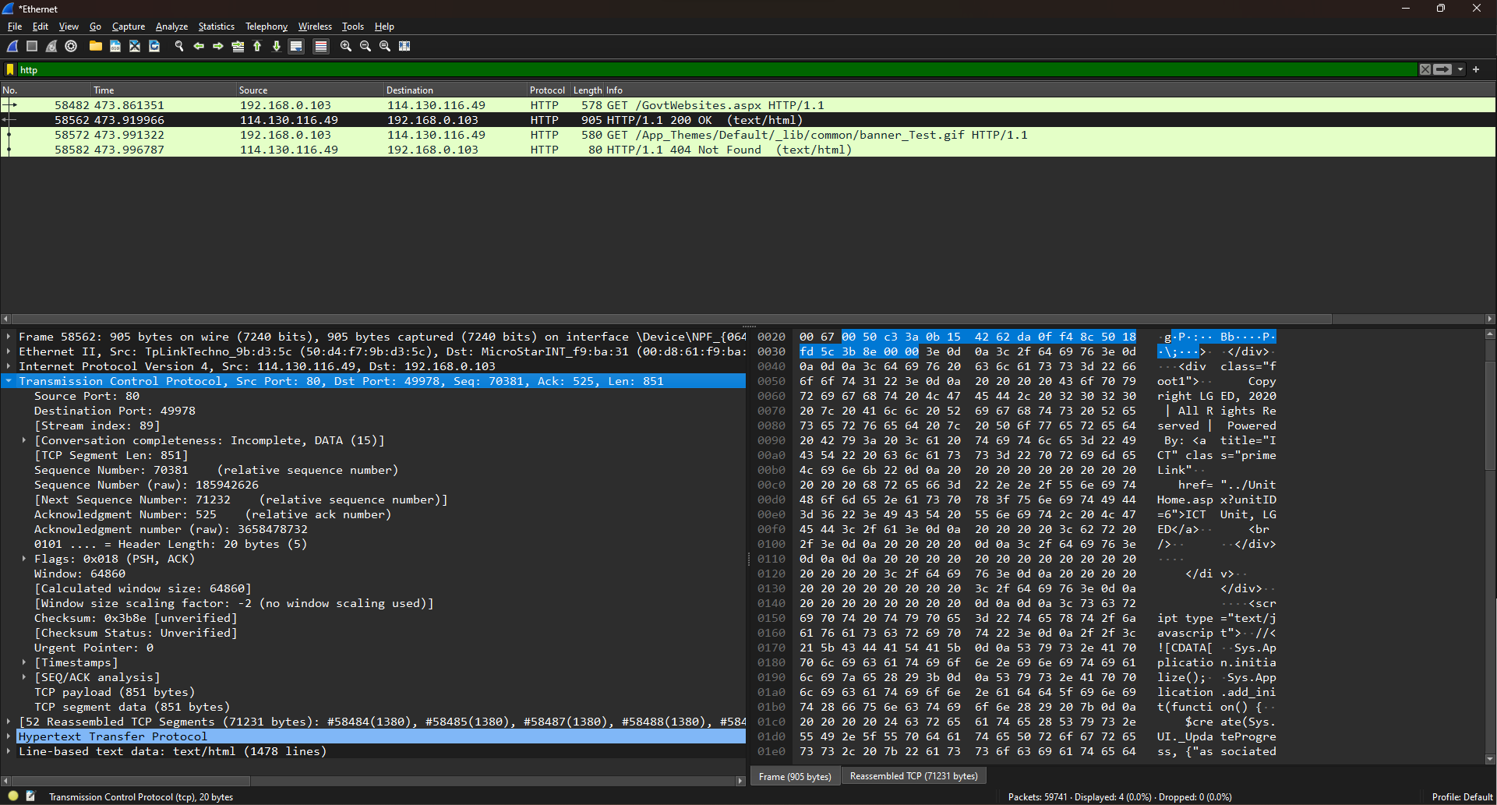

1. **HTTP:**

This is a server HTTP response indicating the success of the request with a status code of 200 OK under HTTP version 1.1. The server is powered by Microsoft-IIS, and the response was generated on Sat, 17 Feb 2024 18:55:01 GMT. The content type is HTML with a charset of UTF-8. The response is sent in chunks, and the connection is maintained open for future requests. This response is 1/2 responses in this session, with specific references to previous and subsequent requests and responses. The request URI specifies that this response corresponds to a request for http://oldweb.lged.gov.bd/GovtWebsites.aspx.

